Clean Power Alliance Power Response Newsletter item for the Chambers of Commerce, CBOs and Member Agencies – March 28, 2022

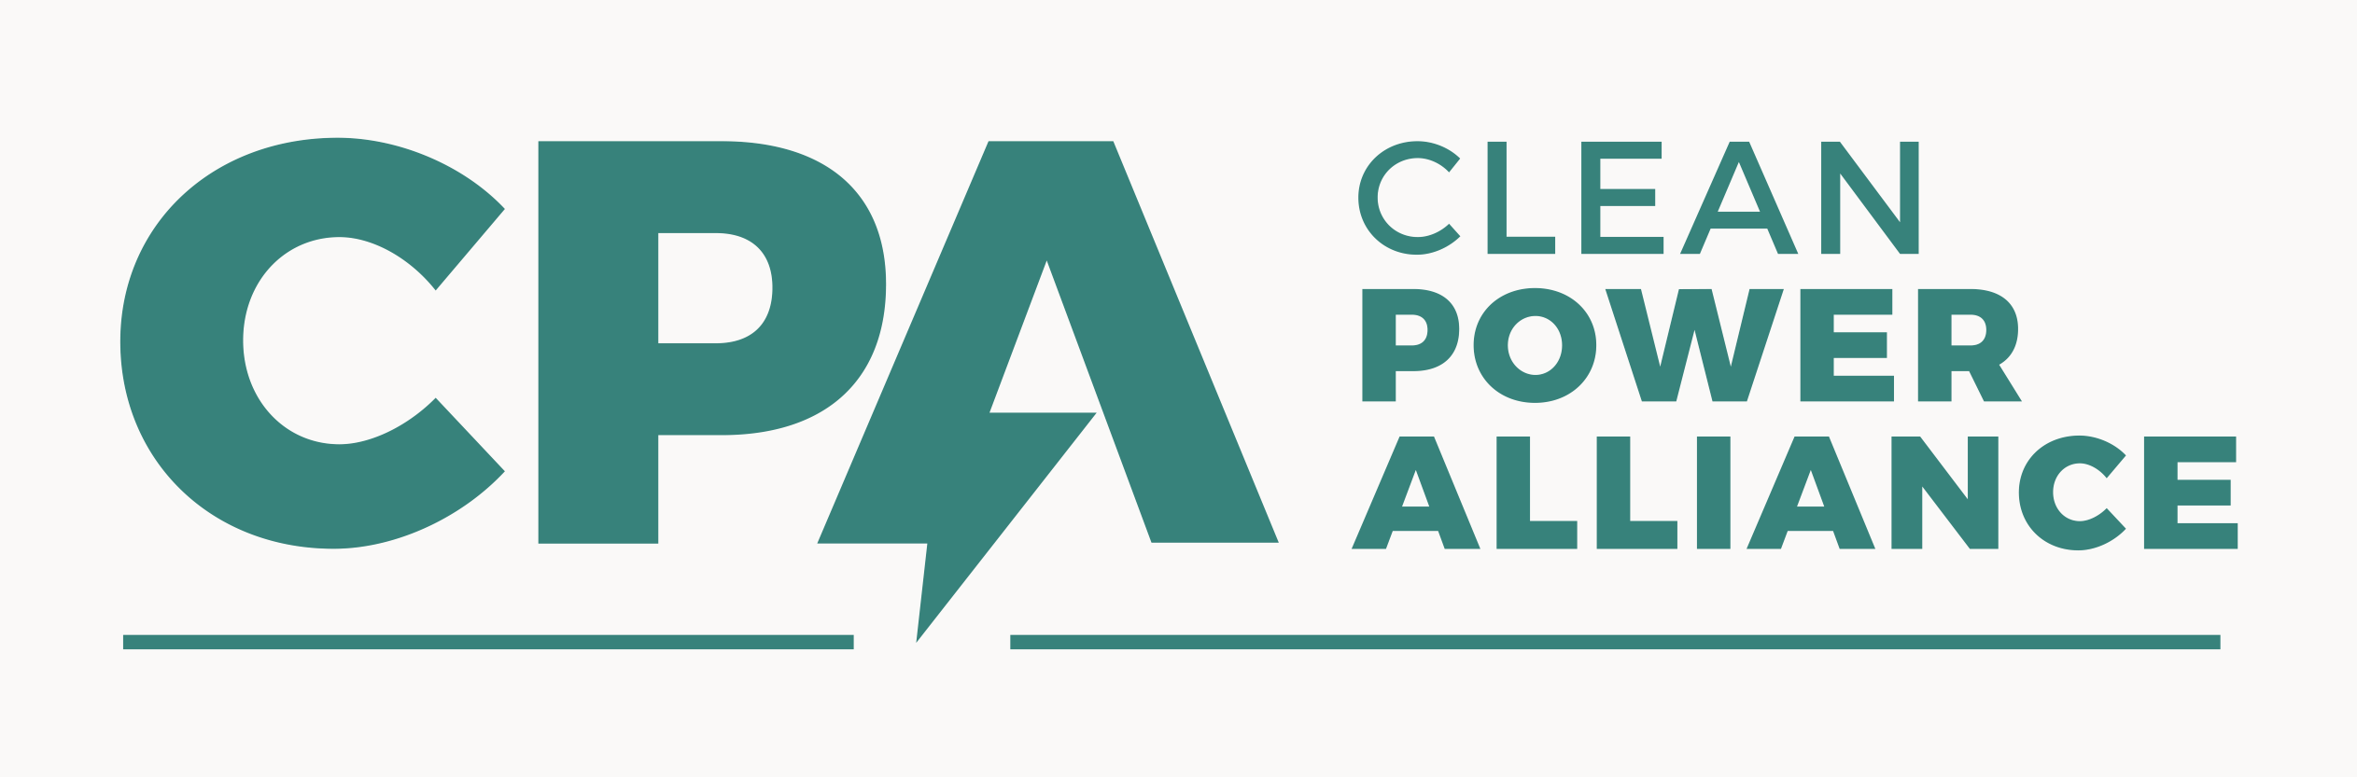
Clean Power Alliance (CPA) recently expanded its successful Power Response program, which encourages participating residential and commercial customers to reduce their energy usage by offering financial incentives. The Power Response program is a demand response initiative utilized by CPA to shift energy usage to mornings, afternoons, or late at night when clean energy is more abundant. Such demand response initiatives help reduce the need for service interruptions, like rolling blackouts, and reduce greenhouse gas (GHG) emissions.
Participation in the Power Response program is extraordinarily easy. After enrolling, customers will receive their sign-up incentive and then are not required to do anything to participate because their Wi-Fi-enabled device – such as thermostat, EV charger, or energy storage system – will automatically adjust when an energy savings event occurs.
Residential customers can participate with a Smart Thermostat, EV Charger, or solar and energy storage system. For customers that don’t have a smart thermostat, CPA is also offering a limited number of free smart thermostats. Residential customers may enroll in the program at: https://cleanpoweralliance.org/power-response/#earnmoney.
Commercial customers can participate by enrolling a Level 2 electric vehicle charging system with a minimum of three EV charger units and minimum 5-kilowatt capacity, or an energy storage system with a minimum 10-kilowatt capacity per facility. Commercial customers may enroll in the program by contacting powerresponse@cleanpoweralliance.org or CPA’s Power Response customer support managed by AutoGrid at 888-292-0502.



